**Unit 1 Investigation 1**

Name: ____________________________

Period: _____

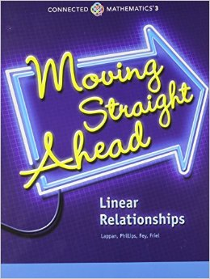

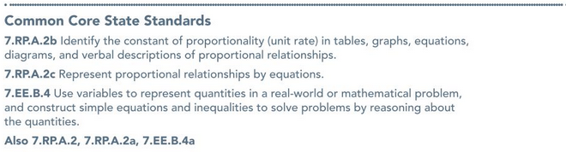



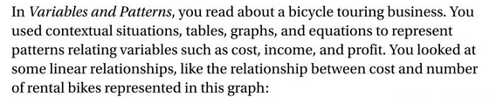

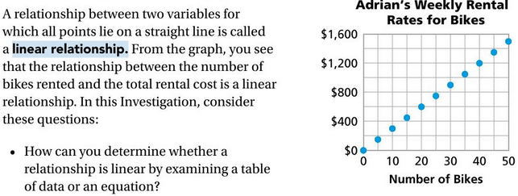



**Investigation 1.1 Notes:**

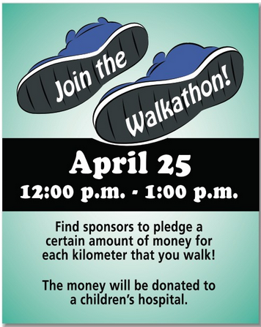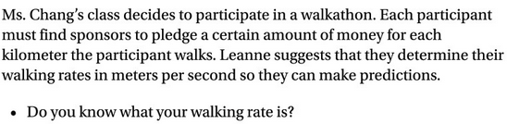



**Problem 1.1:**

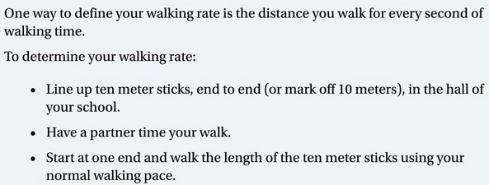



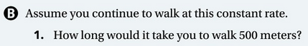









**Investigation 1.2 Notes:**

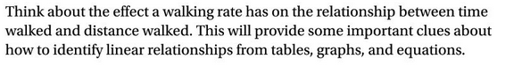

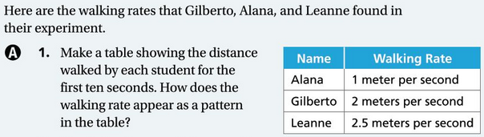**Problem 1.2:**

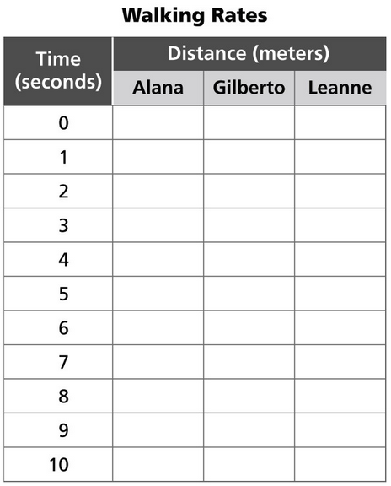

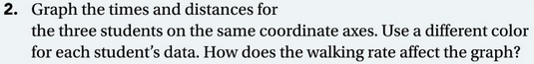

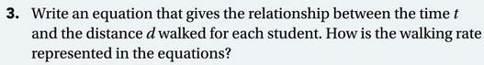





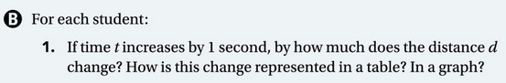





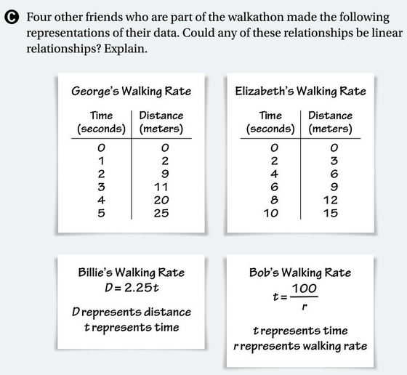

**Investigation 1.3 Notes:**

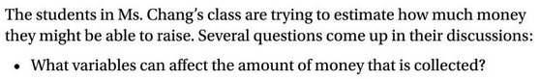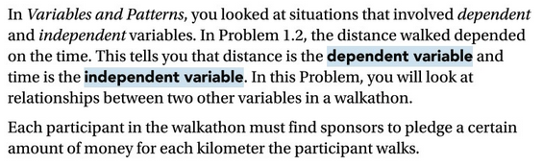





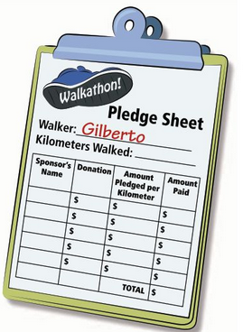

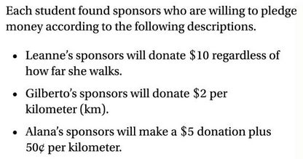

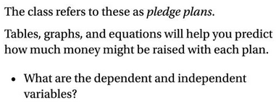

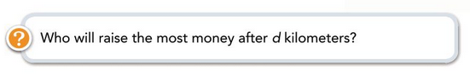

**Problem 1.3:**

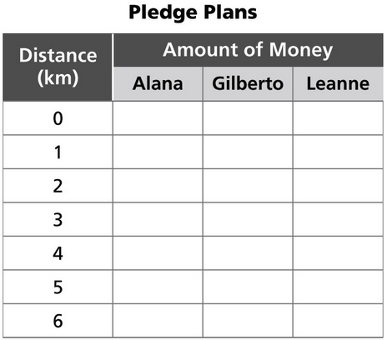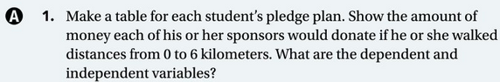



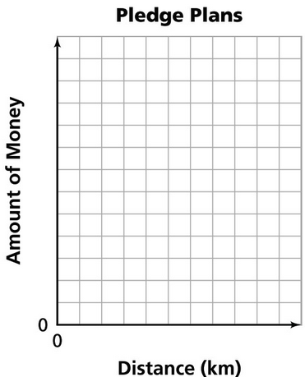

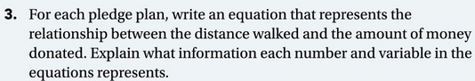

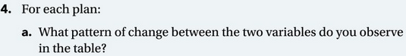

Alana:

Gilberto:

Leanne:



Alana:

Gilberto:

Leanne:



From a table:

From a graph:

From an equation:



Alana: Gilberto: Leanne:

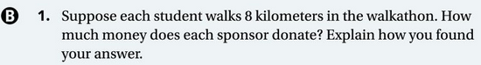











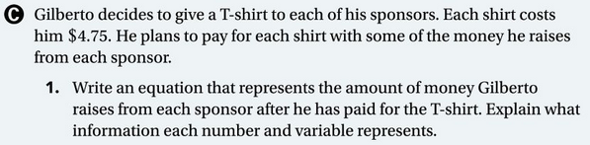







**Investigation 1.4 Notes:**

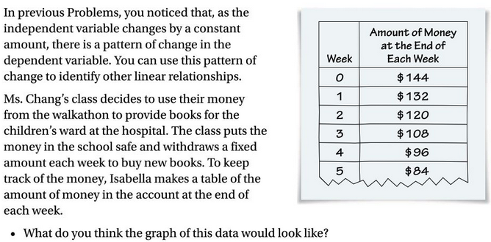



**Problem 1.4:**











